Actual requirements:

We need to setup following: VPC with two public, two private and two database

1. Setup one EC2 instance in private subnet. Install Word Press in the location /var/www/html
2. And EFS Drive should be mounted to the machine at location /var/www/html/wp-content/uploads
3. One Aurora MySQL should be deployed into db private subnet and Word Press needs to use that database.
4. Word Press EC2 should be in auto scaling group with one AMI
5. In order to access Word Press you need to use AWS ALB deployed into public subnet

***FINLA WORK AS PER BLOW :-***

***We need to setup following: VPC with two public, two private and two databases.***

1. Setup one EC2 instance in private subnet. Install Word Press in the location /var/www/html.
2. Word Press ec2 with load balancing and should be auto scaling.
3. And EFS Drive should be mounted to the machine at location /var/www/html/wp-content/uploads.
4. One Aurora MySQL should be deployed into db private subnet and Word Press needs to use that database.
5. Word Press EC2 should be in auto scaling group with one AMI.
6. In order to access Word Press you need to use AWS ALB deployed into public subnet.
7. AMI for word press auto scaling is created by packer.
8. Domain also we have to use for hosting word press web. By (route53, ssl certificate, hosted zone )

**WORK AS PER :**

1. VPC – NETWORKING two public, two private and two databases.
2. LADBALANCER – APPICATION
3. PRIVET SUBNETS WITH EC2 WITH AUTOCASLIG

3.1) AMI for word press auto scaling is created by using packer and used for auto scaling group as AMI .

3.2) AMI CREATED BY PACKER WITH WORDPRESS : wp-confing.php >> set db name , dbuser

dbpassword , db endpoint , elastic cashes endpoint. By shell script.

3.3) ALL EC2 will be have “/var/www/html/wp-content/” check it if is not presents “wp-content/uploads”

Create it by shell script and attach “efs” “ELSATIC FILE STOREGE” to each of the new server for word press new ec2 get generated when AUTOSCALING IS happen . (EFS IS COMMNE STOREGE FOR ALL WORD PDRESS SERVERS)

3.4) Auto scale with the rules – 1) scale up cpu utilization is more than 50% = cpu utilization > 50%

2) scale down cpu utilization is less than 30% = cpu utilization < 30%

1. DB SUBNETS : IT should have 1 writer and 1 standby ec2 for db , mysql. Endpoint is used for the worp dress wp-confing.php
2. Create Domain also we have to use for hosting word press web. By (route53, ssl certificate, hosted zone ) and attach to auto scaling group.

Final OUT PUT SCREEN SHOTES:

1. WORDPRESS WEB WITH DOMAIN : <https://wp.dev.de..../wp-admin/>

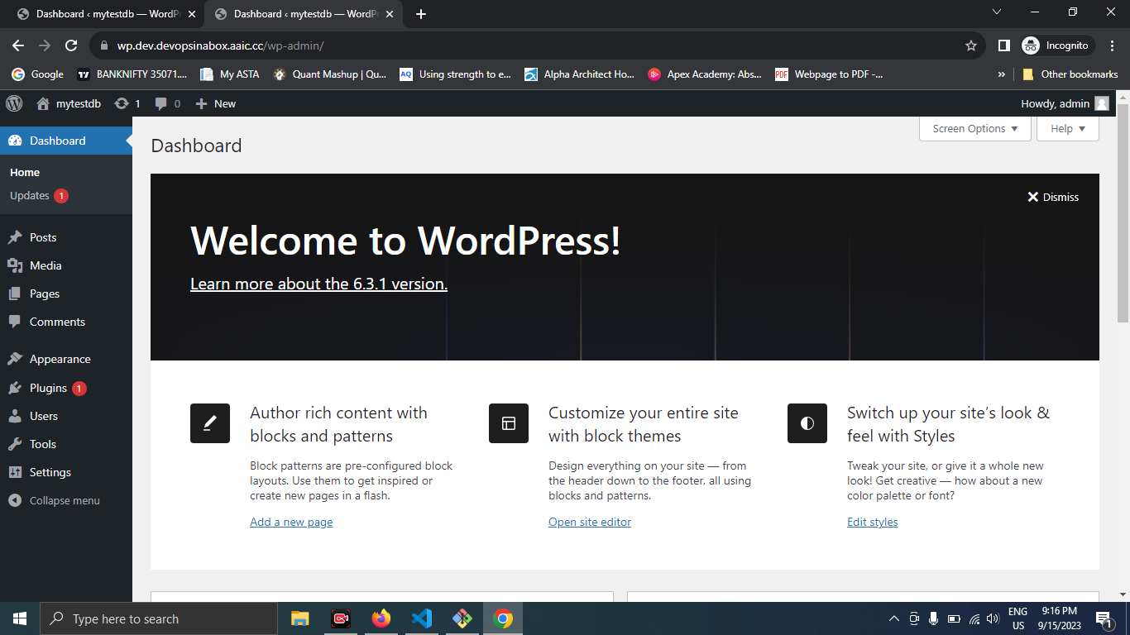

1. EFS ATTACHED FOR EC2

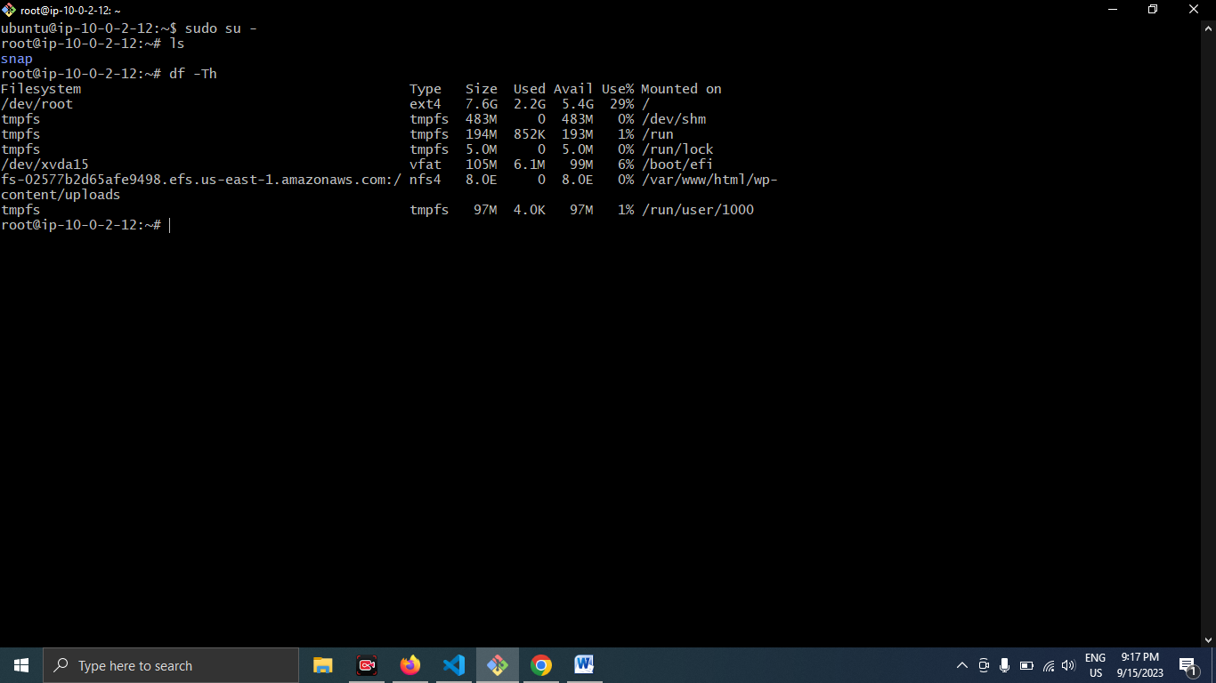

1. RESOURCES ARE ATTACHE CRETED AND USED

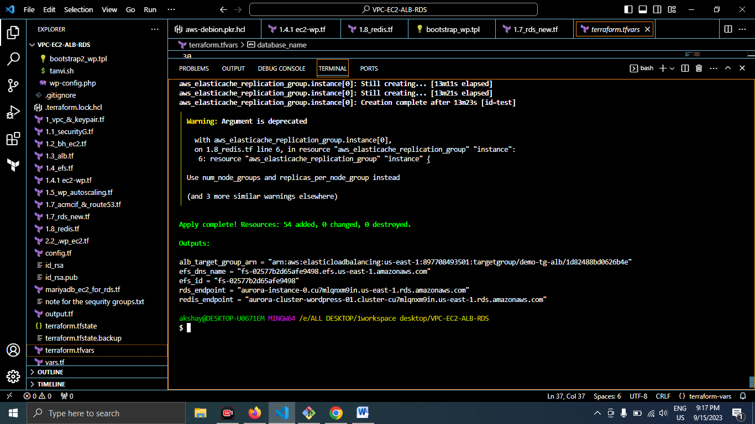

1. AURORA CLUSER FOR THE RDS: WE USE (1 WRITER/READER)

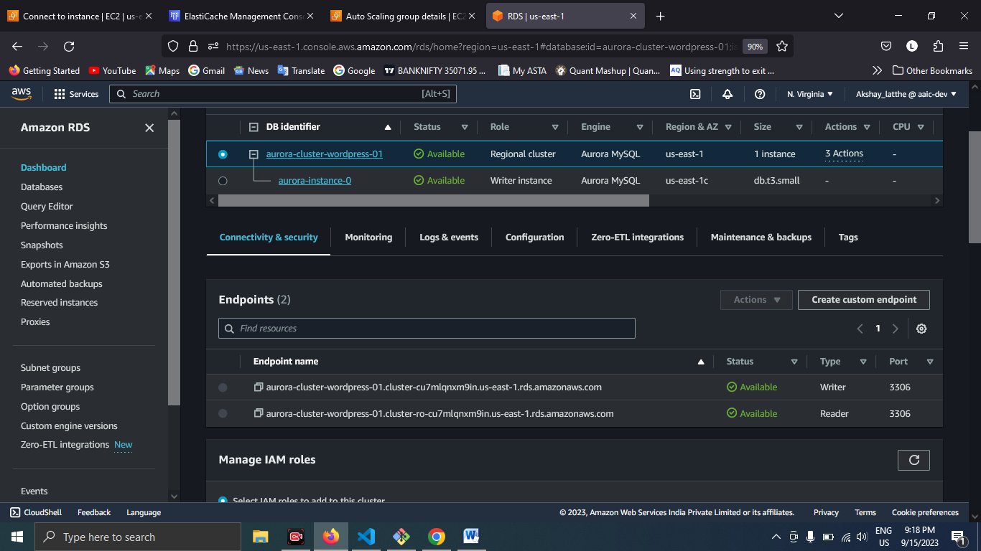

1. REIDS FOR THE ESLAIC CASHE

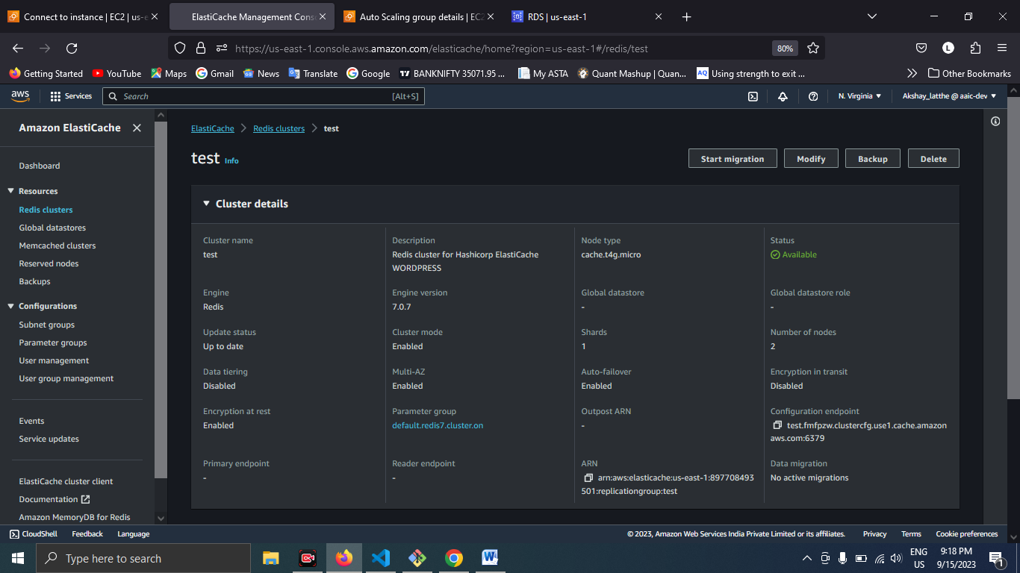

1. AUTO SCALING FOR THE WORDPRESS

